

**LOS ANGELES UNIFIED SCHOOL DISTRICT**

**Office of Communications & Media Relations**

333 South Beaudry Avenue, 24th Floor

Los Angeles, CA 90017

(213) 241-6766

(213) 241-8952 fax

[www.lausd.net](http://www.lausd.net)

**NEWS ADVISORY**

For Immediate Release March 9, 2018

Contact: Ellen Morgan: 213-241-6766 #17/18-156

LD Central: Russell Copley: 213-241-0189

**LOCAL DISTRICT CENTRAL COMMEMORATES THE 1968 STUDENT WALKOUTS AT THE 2018 PERFORMING ARTS FESTIVAL**

Showcasing the Impact of Performing Arts on Community Cohesion & Social Justice

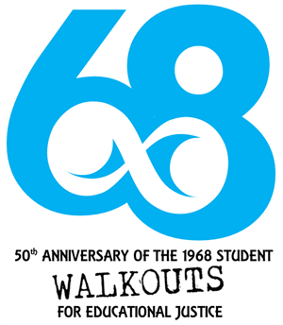WHAT: As part of the Vision ’68 program, Local District Central schools in L.A. Unified will celebrate the spirit of inclusion, equality, tolerance and freedom of expression through the arts. They will bring attention to the amazing talents of students and teachers in this highly creative region of our city. Performing Arts students from 46 schools will perform on four sound stages, and be coached by industry professionals from a range of 18 arts organizations. At the end of the day, 1,400 students will join in a celebratory FLASHMOB event, combining 13 orchestras, 22 dance teams, five choirs and five theatre ensembles with a unified rendition of the civil rights anthem, “We Shall Overcome.”

WHO: L.A. Unified Board President Mónica García

L.A. Unified Board Member Dr. Ref Rodriguez

L.A. City Councilmember Curren Price, 9th District

L.A. Unified Interim Superintendent Vivian Ekchian

L.A. Unified Local District Central Superintendent Roberto A. Martinez

L.A. Unified Parent/Community Services Administrator Dr. Rosalinda Lugo

L.A. Unified Chief of Staff Alma Peña-Sánchez

L.A. Unified Executive Director of Arts Education Rory Pullens

L.A. Unified dance, theatre and music teachers and their students

Industry professionals: Straight Up Abilities, LA Opera, BrockusRED, Diavolo, Center Theatre Group, the Music Center and many others.

WHEN: Saturday, March 10

9:00 a.m. to 2:00 p.m.

WHERE: Dr. Maya Angelou Community High School

300 E. 53rd St., Los Angeles, CA 90011

###